Pass  - The buck!!  Do you have an owner who can’t sell??  If yes, earn cash without the hassle by “passing the buck” to Renters Warehouse. We’ll help your clients rent their home now and send them back to you when they are ready to sell! Just email us at sevasales@renterswarehouse.com.  How it works:  Submit your contact information below to Renters Warehouse  Agent Name: ________________________________  Agent email: _________________________________  Agent Phone: ________________________________  Homeowner name: ___________________________  Homeowner email: ____________________________  Homeowner phone: ___________________________  Property address: _____________________________  Brokerage name: ______________________________  Brokerage address: ____________________________  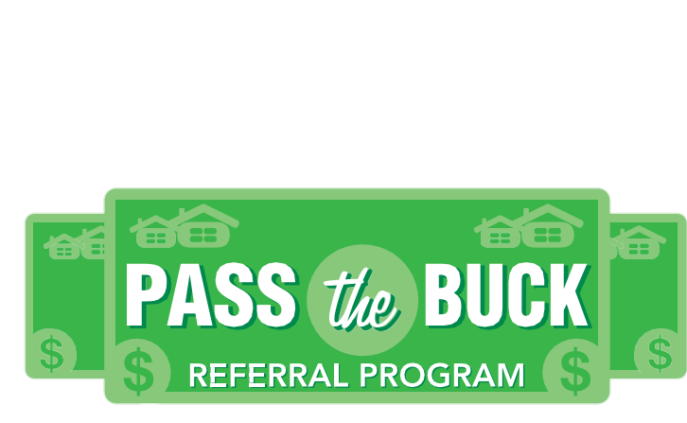  **Agent agrees to list home in the last 30 days of tenant lease and to work closely with Renters Warehouse to make sure repairs are not requested until security deposit disposition has been executed. ** | $1000 referral per new management contract (Tenant placement and property management)!!  Our guarantee:  Renters Warehouse will NEVER assist your client in buying or selling real estate; now or in the future.  You Have Room for Another One Here!  Renters warehouse  1354 Kempsville Rd  Suite 102  Chesapeake, Va 23320  757-272-1616  sevasales@renterswarehouse.com  Mon-Fri 8-4

